The New Bedford Public Schools Division of Adult/Continuing Education conducted an Open House and Family Literacy Day on November 1 to mark National Family Literacy Month. This annual Family Literacy Day affords an opportunity for the adult education students to invite their children, family members, or friends to visit the school, meet the teachers, and engage in literacy-based activities.

This year, Pamela Kavanaugh and Martha Gonzalez from the Greater New Bedford Community Health Center provided the adult education students with an overview of the health services available to area residents. Greater New Bedford Career Center staff members, Maria Grace and Tania Costa, informed learners of the free services available.

Adult learners in the day and evening programs and members of their families also participated in a variety of interactive literacy sessions which were planned with the ages and interests of the adult students’ children in mind. To further emphasize the importance of literacy, all children participating in the day’s activities received an age-appropriate book to add to their personal collections. The teachers in the Adult Learning Center morning program contributed to purchasing the children’s books, while the evening students received books donated by literacy volunteer John Tavares who is also a member of the Friends of the Acushnet Public Library.

The NBPS Division of Adult/Continuing Education is committed to providing adult learners with opportunities to develop their reading, writing, mathematics, and computer skills, and to earn a GED or high school diploma. The school also offers English classes for non-native speakers. The Adult Education program always welcomes volunteer tutors to assist adult learners in the classroom. For information about enrolling as a student or volunteering as a tutor, call etc.

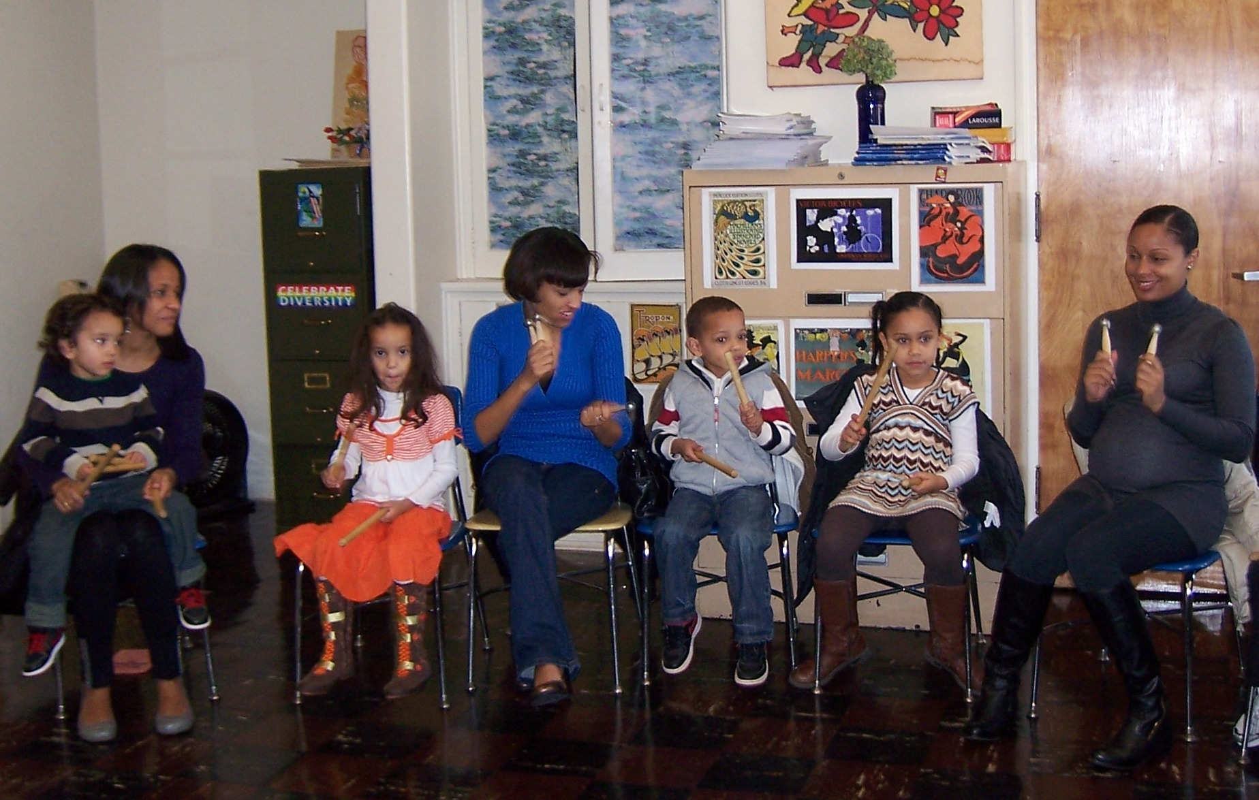
Enjoying making music together are Denzel Ferreira, Jocelyn Fernandes, Adalgisa Fernandes, Jason Fernandes, Kyra Fernande and Nilza Fernandes.

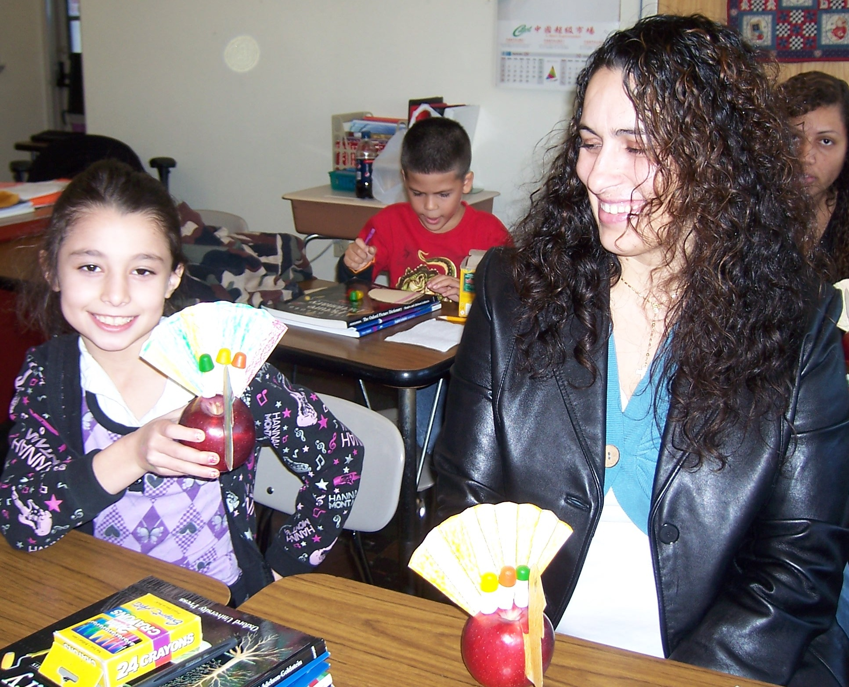
Arts & Crafts projects are completed by Samatha Hora and her mom, Marcia Fontenelle.

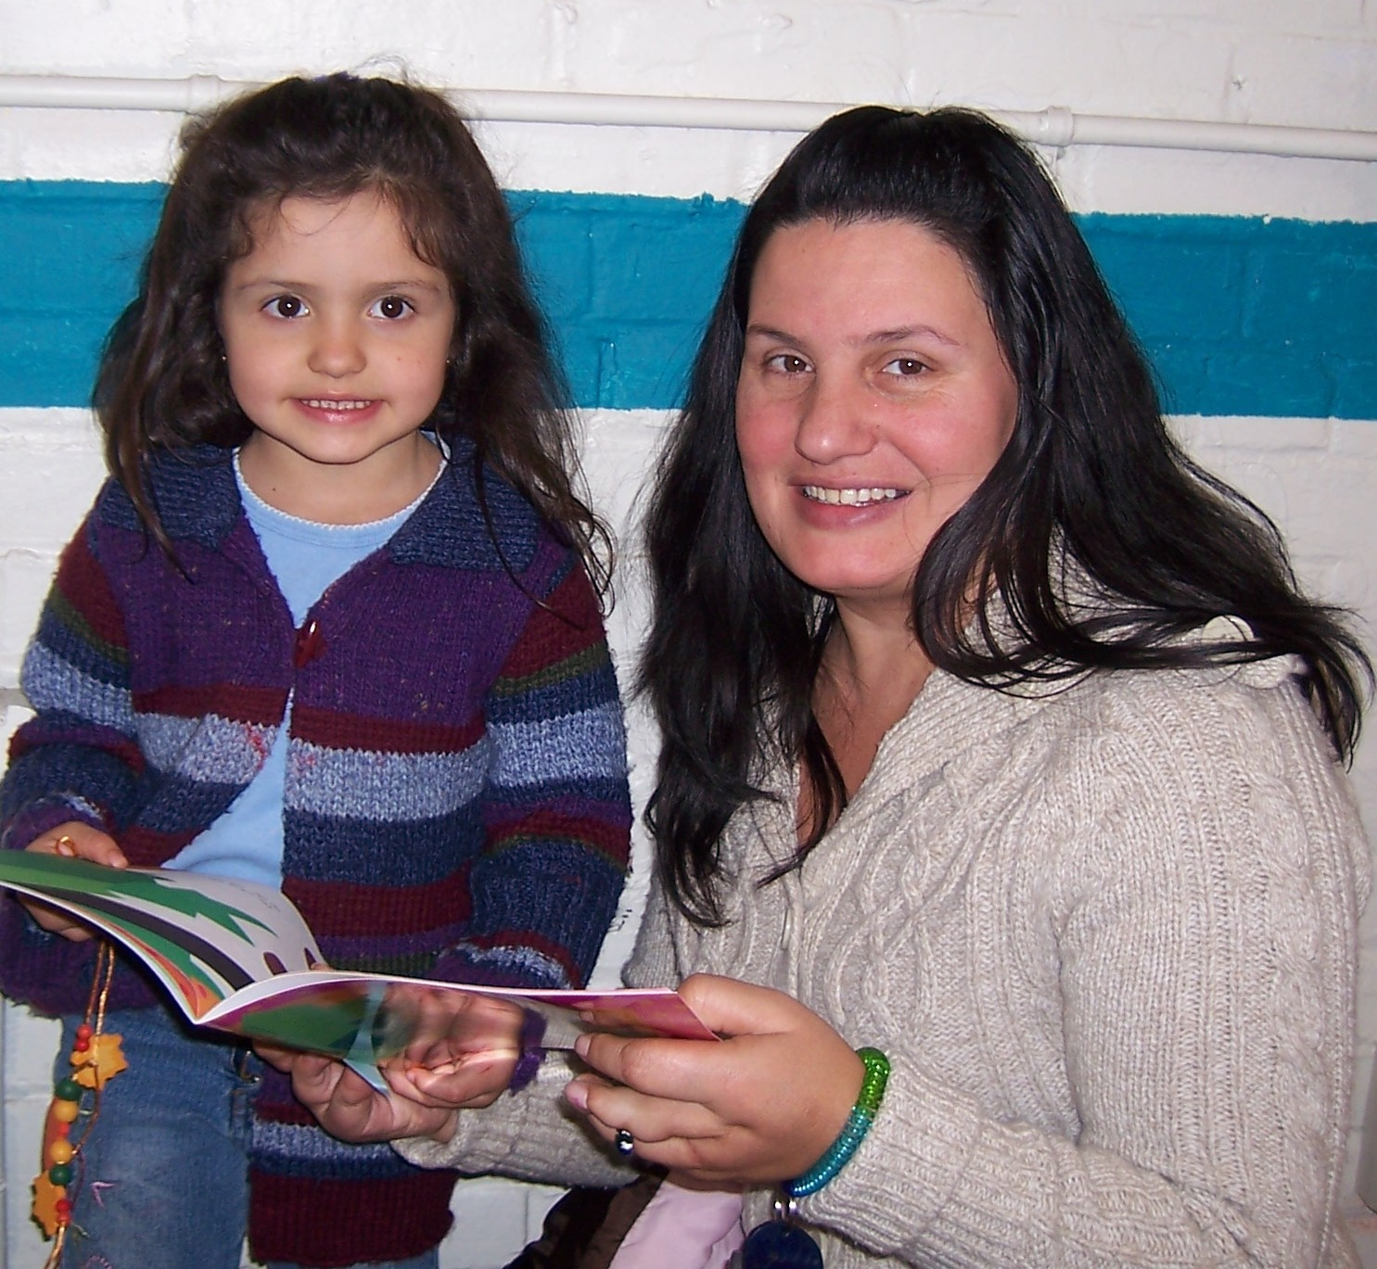
Sharing a new book are Karen Novo and her mom, Anabela Raymond.

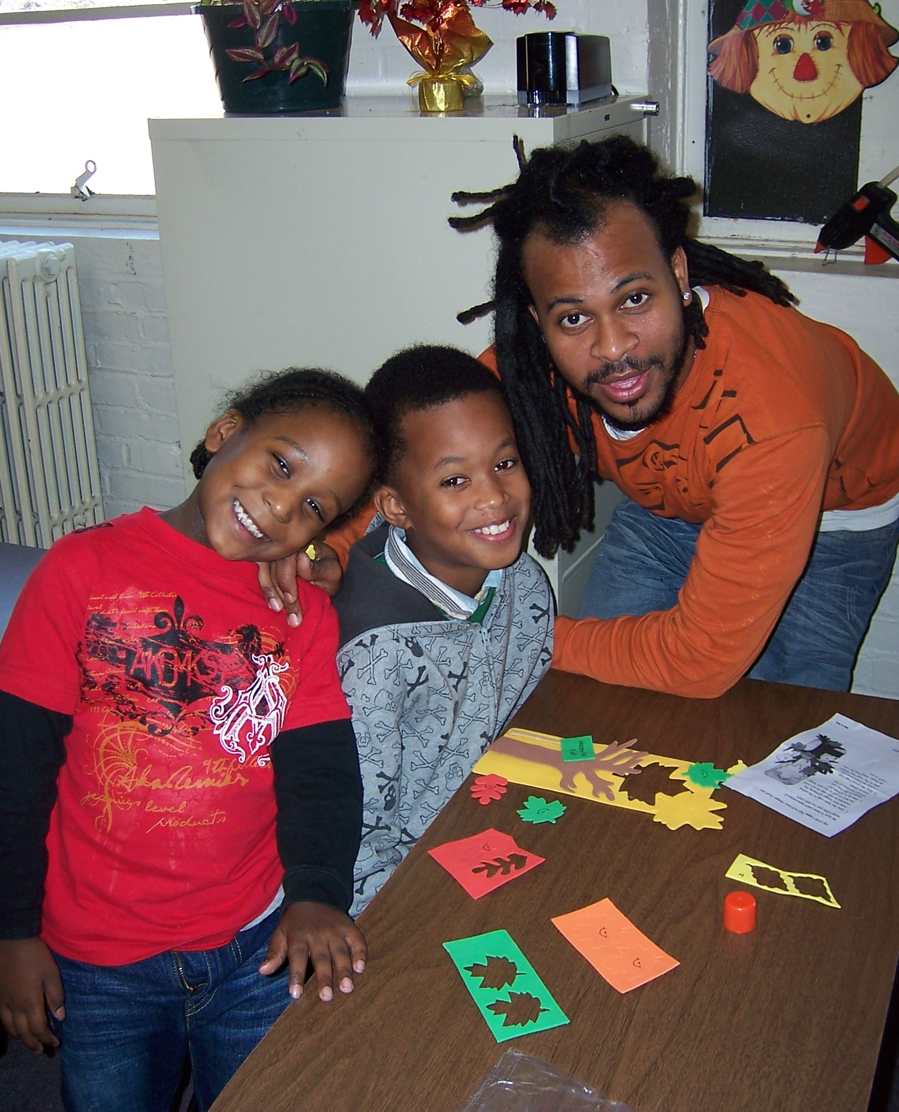
A Fall art project is being worked on by Ilyzick and Igor and their dad, Carlos Lopes.

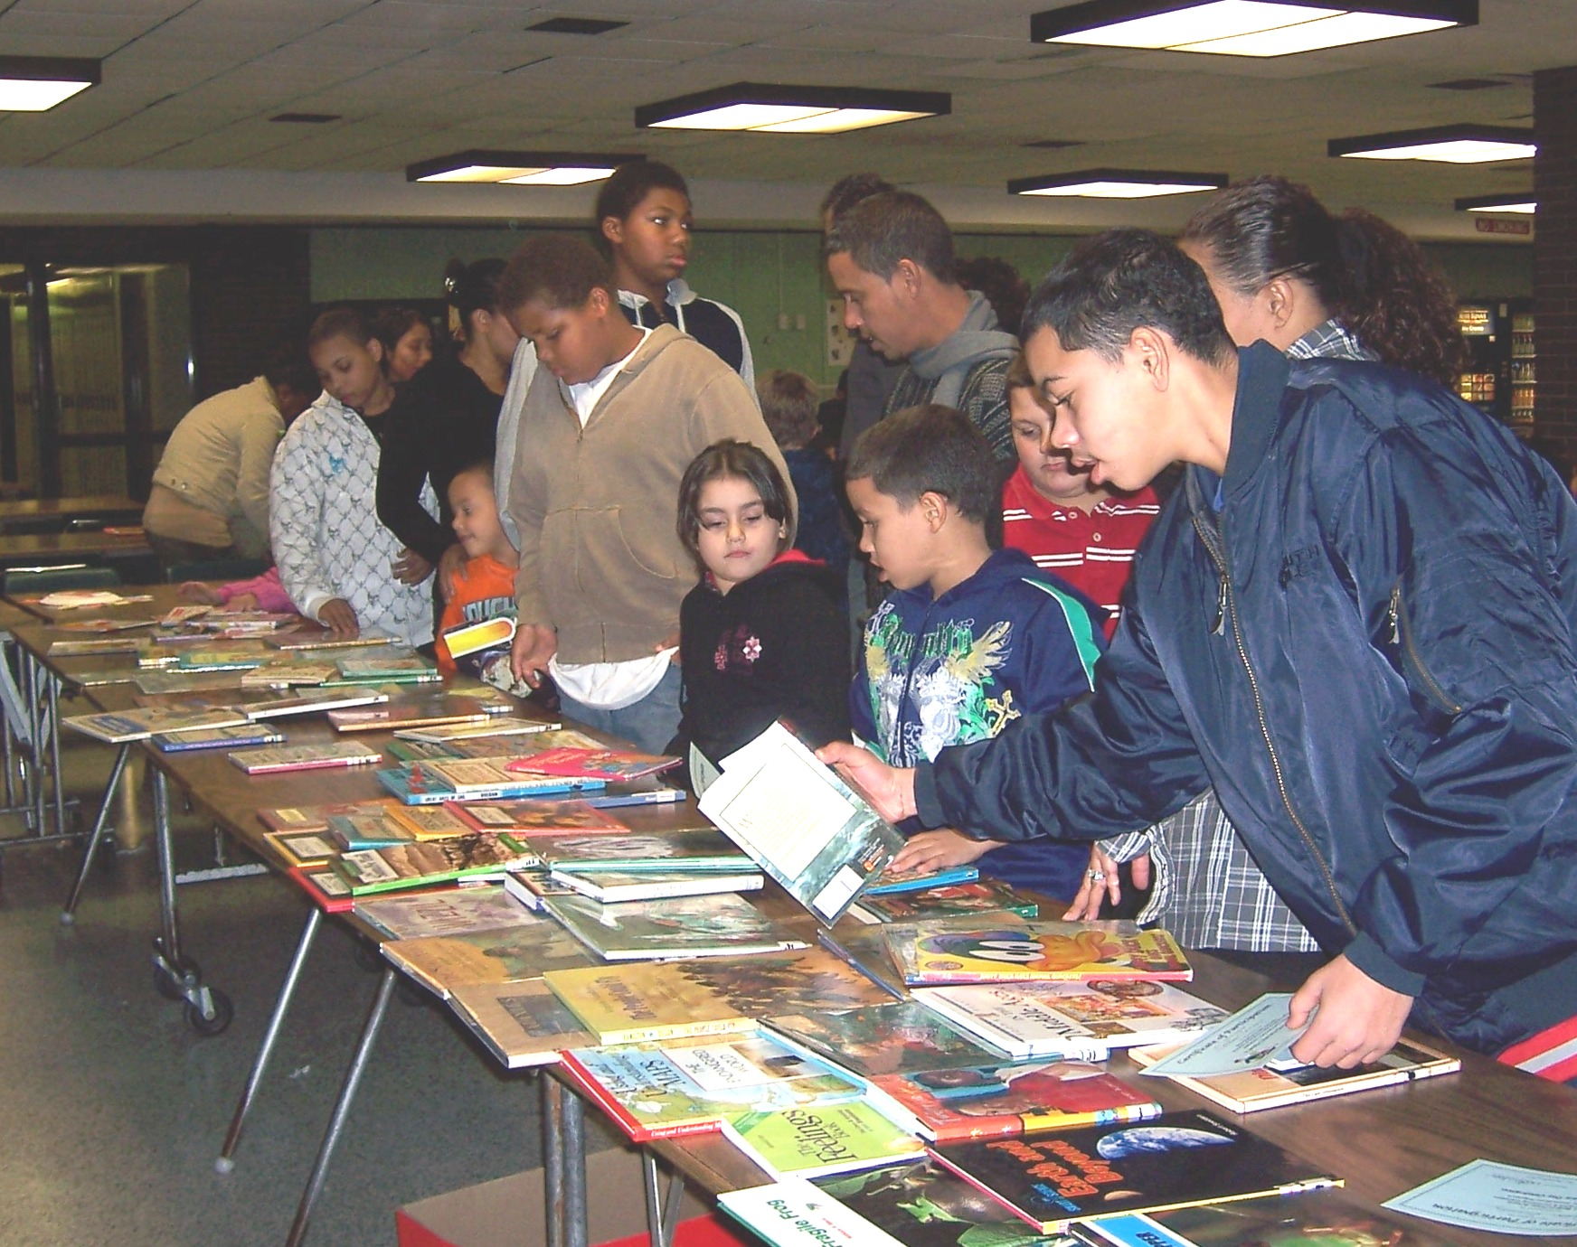
Picking a book to keep!

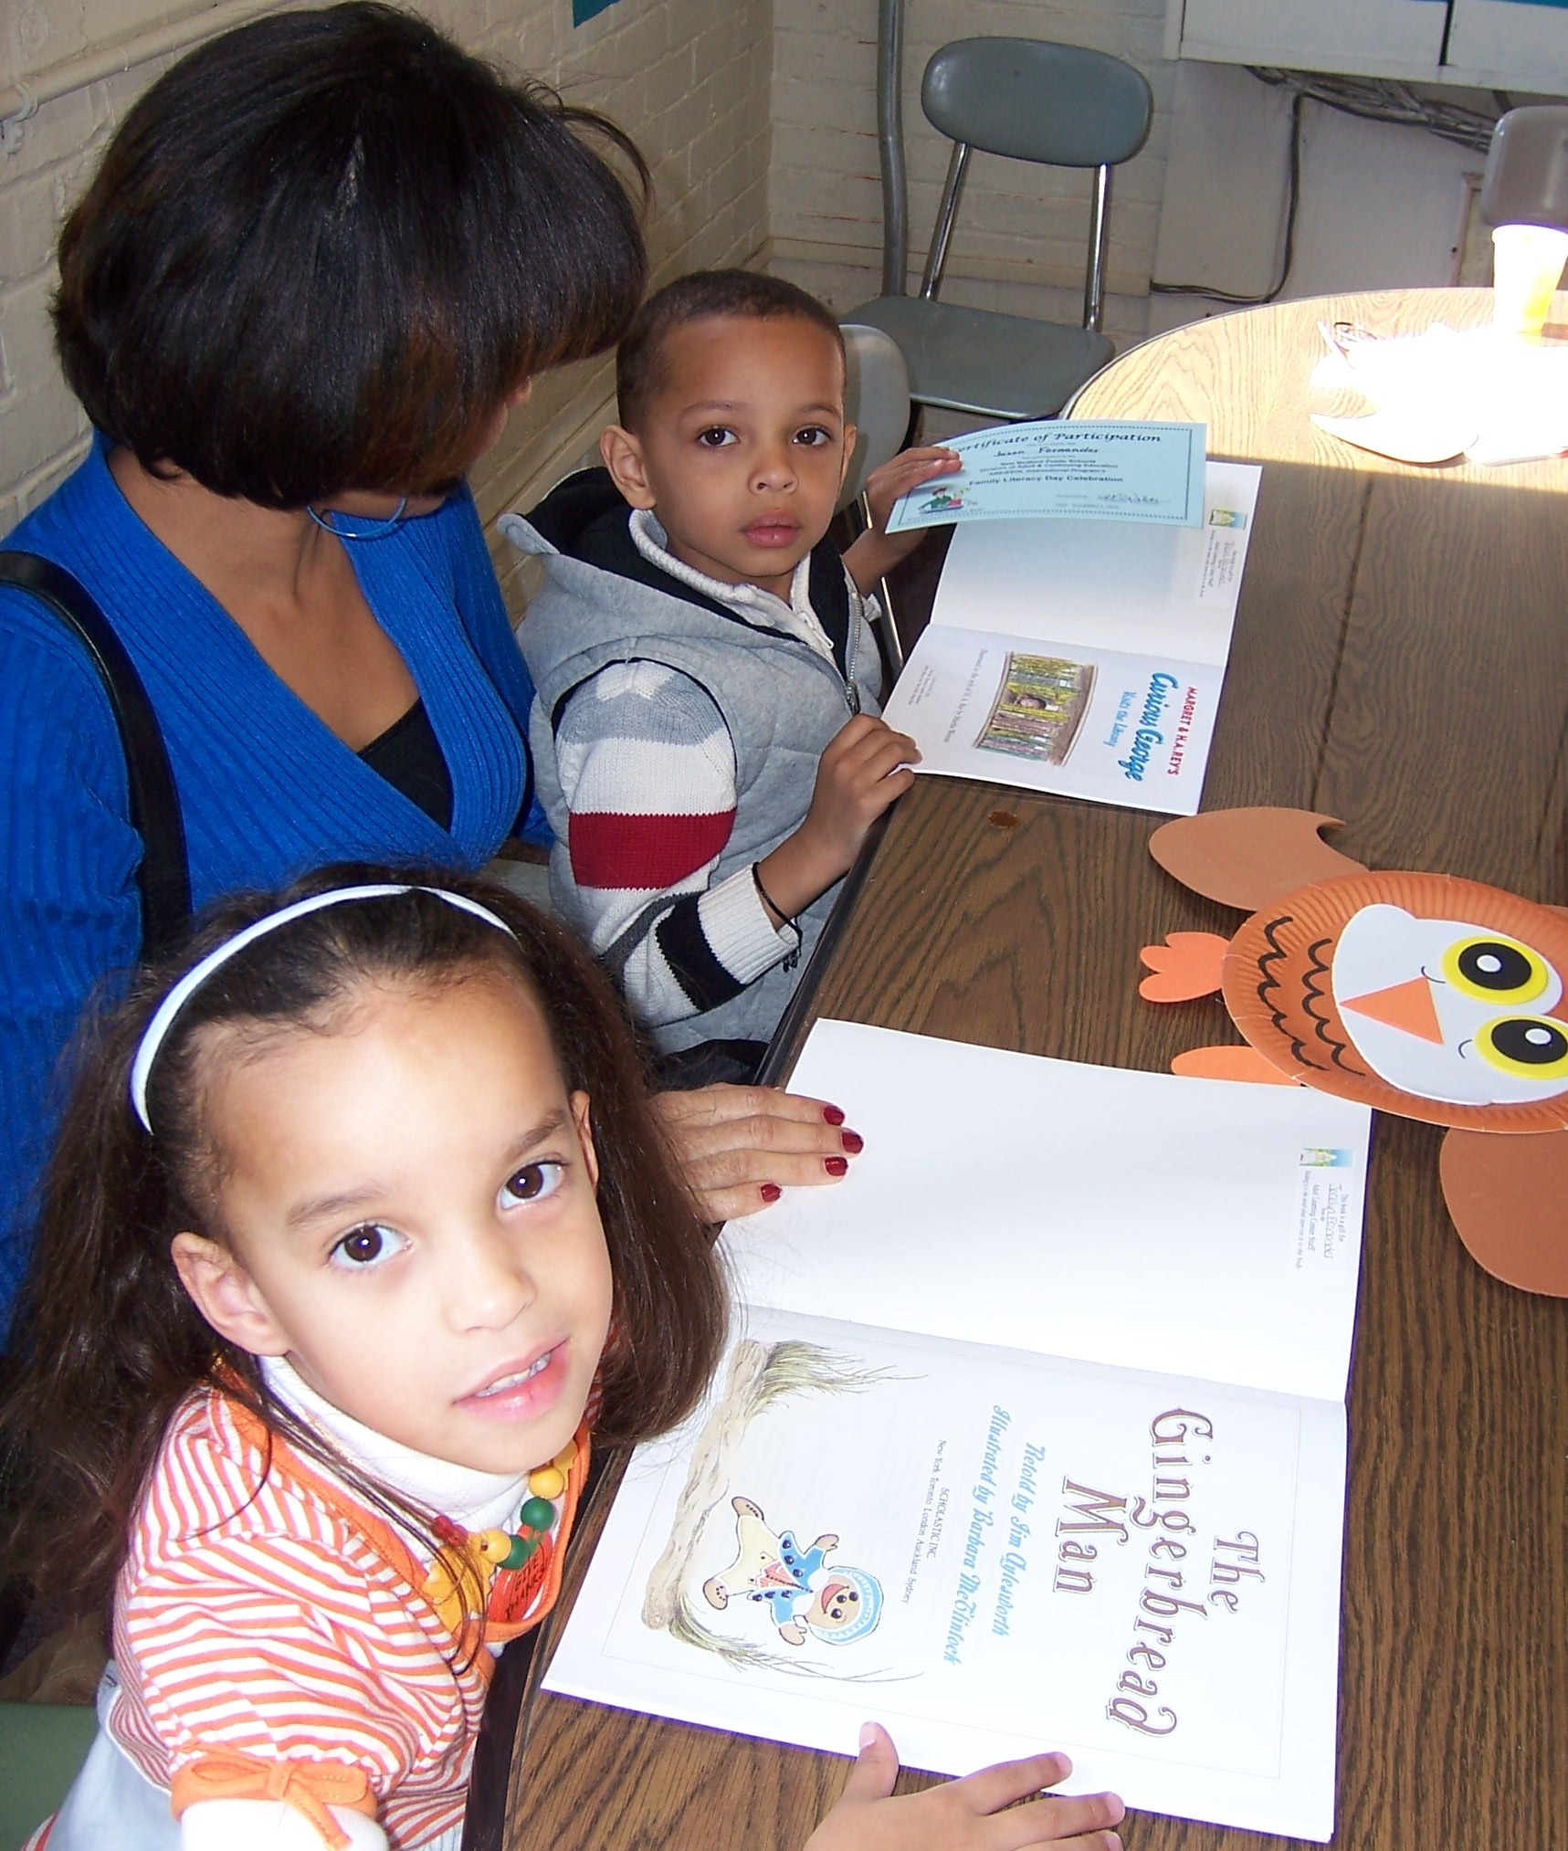
Each child received a book to add to his/her personal library. Looking through the new books are Jocelyn, with mom Adalgisa and brother Jason Fernandes.

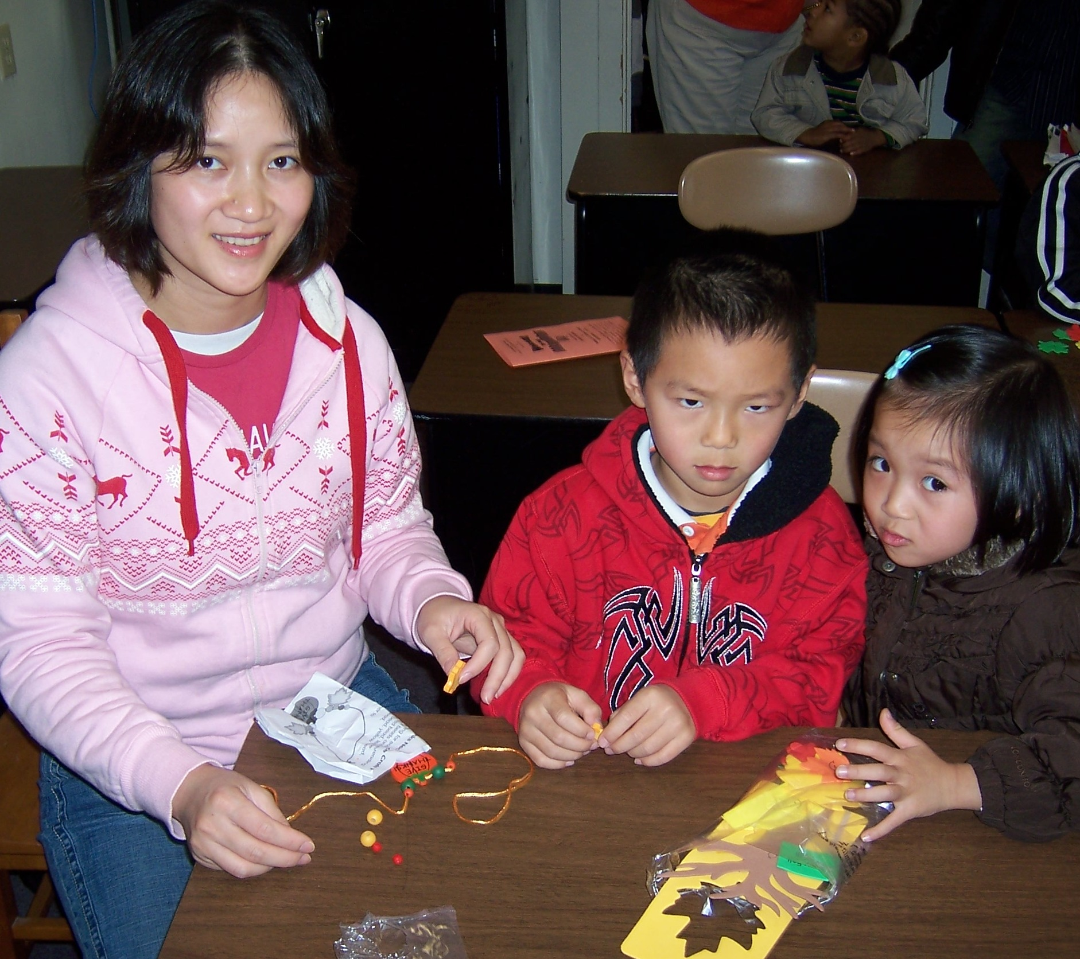
Working on a beaded necklace, Mom and children.

