Lesson 3: Activity 1
Types of Tax Systems
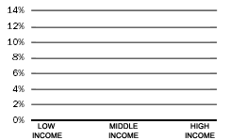
Low Income
Middle Income
High Income
Regressive

When people who have more money pay a smaller part (percentage) of their income in tax than people who have less money, it's called a "regressive" tax system.

Low Income
Middle Income
High Income
Flat

When all people pay about the same part (percentage) of tax on their income, it's called a "flat" tax system.

Progressive
Low Income
Middle Income
High Income

When people who have more money pay a higher part (percentage) of their income in tax than people who have less money, it's called a "progressive" tax system.

Adapted from Massachusetts Budget Crisis: Who Hurts? Who Pays? (United for a Fair Economy and the Massachusetts Budget and Policy Center)

Lesson 3: Activity 1 - Types of Tax Systems bars for graphs

Bars for Regressive Tax:




T
A
X
T
A
X
T
A
X

Bars for Flat tax:

T
A
X
T
A
X
T
A
X

Bars for Progressive Tax:

T
A
X
T
A
X
T
A
X
Adapted from Massachusetts Budget Crisis: Who Hurts? Who Pays? (United for a Fair Economy and the Massachusetts Budget and Policy Center)

Lesson 3: Activities 1 and 2 - Types of Tax Systems matching activity
Types of Tax Systems
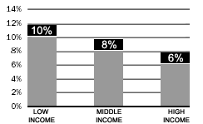
T
A
X
T
A
X
T
A
X
Low Income
Middle Income
High Income
Regressive

When people who have more money pay a smaller part (percentage) of their income in tax than people who have less money, it's called a "regressive" tax system.

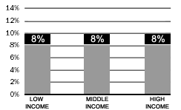
T
A
X
T
A
X
T
A
X
Low Income
Middle Income
High Income
Flat
When all people pay about the same part (percentage) of tax on their income, it's called a "flat" tax system.

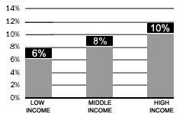
Progressive
T
A
X
T
A
X
T
A
X
Low Income
Middle Income
High Income

When people who have more money pay a higher part (percentage) of their income in tax than people who have less money, it's called a "progressive" tax system.

Adapted from Massachusetts Budget Crisis: Who Hurts? Who Pays? (United for a Fair Economy and the Massachusetts Budget and Policy Center)

Lesson 3: Activity 3 – Who pays state and local taxes?

Lesson 3: Activity 3 - Tax Breaks

Taxes paid before Taxes paid now

Lesson 3: Activity 3

Lesson 3: Activity 3 - Tax Breaks examples
Taxes paid before Taxes paid now

Massachusetts income tax cut

Taxes paid before Taxes paid now

Corporate tax break
Lesson 3: Activity 3 - Tax Breaks worksheet

Name________________________________________________________________________

Here are the names of the tax breaks we talked about:
Taxes paid before Taxes paid now Taxes paid before Taxes paid now

Corporate tax breaks Massachusetts income
tax cut

Here are some situations. Write the correct tax break under the situation.

- It is 1994. The company Fidelity Investments sells one of their products (mutual funds). It pays taxes to the Massachusetts government on the money it makes. Now it is 1996. Fidelity Investments sells some more mutual funds. It pays less money for taxes than it paid in 1994.

____________________________________________________________________________________

- It is 1999. Abdulle makes $1 million at his job. He pays taxes to the Massachusetts government on this money. Now it is 2001. Abdulle makes the same amount of money, but he pays over $5,000 less for taxes than he paid in 1999.

_____________________________________________________________________________

- It is 1994. The company Raytheon sells some airplanes. It pays taxes to the Massachusetts government on the money it makes. Now it is 1996. Raytheon sells some more airplanes. It pays less money for taxes than it paid in 1994.

_____________________________________________________________________________

- It is 1999. Sandra makes $20,000 at her job. She pays taxes to the Massachusetts government on this money. Now it is 2001. Sandra makes the same amount of money, but she pays only about $85 less for taxes than she paid in 1999.

_____________________________________________________________________________
Lesson 3 Assessment

Student name_________________________________ Date________________

- Here is the information you will learn in this lesson. Before class begins, only look at the information below, to see what you will learn.

- After the lesson, when your teacher tells you to, circle what you have learned.

You can name and describe 3 tax systems:

Regressive Progressive Flat
You can name and describe 2 tax breaks:

Corporate tax breaks Massachusetts income tax cut
You can say why you think one way to tax people or one tax break is
fair or not fair:

Yes No

Student name_________________________________ Date________________

- Here is the information you will learn in this lesson. Before class begins, only look at the information below, to see what you will learn.

- After the lesson, when your teacher tells you to, circle what you have learned.

You can name and describe 3 tax systems:

Regressive Progressive Flat
You can name and describe 2 tax breaks:

Corporate tax breaks Massachusetts income tax cut
You can say why you think one way to tax people or one tax break is
fair or not fair:

Yes No

