Lesson 2: Taxes and What They Pay For

Goal
Identify types of taxes. Identify that these taxes pay for state government services, including legislators' salaries.

Objectives
- Given graphic depictions of taxes, identify three types including personal income, sales, and corporate excise, and explain each. The explanations must identify who pays each type of tax.
- Asked the question "Why does the state government collect taxes?", state that taxes pay for government services.

Preparation and materials
- White board/Newsprint
- Markers
- Masking tape
- Pencils/pens
- Paper for students
- Warm-up: Copy of Joe the Taxpayer picture for posting or on overhead projector.
- Activity: Copies of the handout: Where Does the Money Come From? for each student, or put on an overhead.
- Activity: Copies of the handout: Where Does the Money Go? (from Lesson 1) for each student, or put on an overhead.

Introduction

Review: Quickly go over concepts from the previous lesson, asking students to recall the government departments they learned about and some services those departments offer.

Tell students: In this lesson we're going to find out what taxes are, who pays them, and what the government does with the tax money it collects.

Warm-up

Ask students if they know what taxes are. Write any responses on the board. Students may say money and/or government. Encourage a complete definition. Give students a few minutes to brainstorm, then post the Joe the Taxpayer picture on the board and encourage students to give a fuller definition.

- If students haven't been able to give a complete definition of tax by this time, write the following definition on the board: "Money taken by the government from incomes, sales, etc. to pay for government services. " (From English Dictionary for Students. Peter Collin Publishing, 1999.)

- Ask students:
- Did you pay taxes in your country? What kind?
- Do you pay taxes in this country? What kind?

List all appropriate responses on the board under the heading, "Kinds of Taxes." Write any other related responses next to that list.

Ask students:
- Do you think taxes are good or bad? Why? Refer to the picture of Joe the Taxpayer.

- For those who think taxes are bad, point to Joe the Taxpayer and ask these students why Joe seems to appear happy to pay his taxes. What is he thinking?

- Elicit from the class Joe's thoughts about paying his taxes by having them tell you what Joe could be saying in the bubble. This can be done as a quick writing assignment or as a verbal response. Encourage authentic responses. Write them on the board.

Activity

Tell students: Now that we've had a chance to find out what taxes are and whether we think they're good or bad, let's now think about the taxes we pay. Some of you have already told us in the activity before, about the taxes you pay here in the U.S. or taxes you paid in your native country. Let's now think about some different kinds of taxes that we must pay to the Massachusetts state government. There are many kinds, but here we will talk about three.

- Write the following three tax types in columns on the board: Personal Income Tax, Sales Tax, and Corporate Excise Tax. Either distribute Where Does the Money Come From? or put it on an overhead.

- Ask students to give the following definitions, based on the lists of the tax types on the board. If students have difficulty doing this, write the following definitions on the board and invite students to write these definitions in their notebooks or the handouts given with this lesson:

sales tax: Money you pay to the government when you buy certain things. This money is in addition to the price of the good you are purchasing.
personal income tax: Money you pay to the government on the money you make at your job or that you earn from investments. The gross amount on your paycheck is your total income, and the net amount is the amount of money you put in your pocket after giving the government their portion their money.
corporate excise tax: Money that some kind of businesses pay to the government for conducting business in the state. Other businesses like a sole proprietorship or partnership do not pay corporate excise tax. They pay other kinds of taxes.)

- Next ask students who pays the three tax types, for example shoppers, regular citizens, or people who buy things pay sales tax, some business people (or more specifically corporations) pay corporate excise tax, and workers pay income tax. Write their answers on the board in a separate column entitled, "Who pays", matching the responses with the corresponding tax types.

4. Refer students back to the Lesson 1 handout, "Where Does the Money Go?" or overhead. Acknowledge that the government gets taxes or money from many other sources, such as fees for licenses, etc. Ask:

- How much (or what percent) of it's total money does the government get from taxes? A little bit or a lot? What if the government did not collect taxes? (Referring students to the other pieces of the pie) Ask: "Where would they get the money for services?" What would happen to the services without this tax money? (Refer to the handout, Where Does the Money Go)
- Where do most of the taxes come from?
- Does anyone know if the government is getting enough tax money from all of these places to pay for the services we talked about?

Talk briefly about Massachusetts government money problems and let the students know that you will be talking more about this in a later lesson.

- Finally ask students:
- What about the people who work as leaders in the government?
- Do they give the people a service?
- Where do their paychecks come from?

End the discussion confirming that we do receive services like healthcare and education, and that people who work for the government give us services called leadership and that all the taxpayers pay for their salaries. Tell them you will be talking more about who the leaders are and how they provide their services in another lesson.

- Remind students that there are three levels of government and put the following grid on the board without the examples of taxes. Ask students to help you complete the grid.

Government | Examples of money (taxes) we pay
Local | local taxes, fees
State | Income Tax, Sales Tax, Corporate Excise Tax
Federal | Income tax, fees

Discuss any confusion about the different taxes.

Enrichment/extension activities

Beginning ESOL/Literacy students:
- Have students use picture dictionaries to locate vocabulary for Activity 2.
- Give students pictures from retail store flyers (Wal-Mart, CVS, etc.) of taxable and non-taxable items. Have them sort these pictures into taxable and non-taxable piles.
- Have students work in pairs or small groups to discuss items they've bought recently, and make lists of those items. Let them know they can include "big ticket" items like a car or refrigerator, as well as everyday purchases like food and beauty products. Remind them that buying food at a restaurant is considered buying something, and they should include this on their lists. Ask them to include on their lists whether or not they think they paid sales tax on each item. Have a representative from each pair or group report back to the class about their purchases. Encourage students to respond to the presentations.
- Ask students to recall the services the government provides as discussed in Lesson 1. Hand out copies of the handout, Where Does the Money Go? or show on an overhead, and discuss the distribution of tax monies. After, distribute the handout Where Do Massachusetts State Taxes Come From? Where Do They Go? Instruct student to refer to Lesson 1 handouts in completing this worksheet. You can use this activity as an assessment tool by having them work individually. Otherwise they can work in pairs or small groups. Assist the class as necessary by referring them to the taxes and taxpayers as listed on the board. Similarly, instruct them to list the services, using material from Lesson 1 if necessary. End the activity with a review. Ask students: What taxes do we pay? What services do we get in return? Encourage students to elaborate on their responses, allowing them to agree or disagree, and letting them know that you will be discussing whether taxes are fair or unfair in another lesson.

Intermediate/higher ESOL, ASE/high ABE/GED students:
- Collect tax receipts and statements. Have students calculate the amount of taxes reflected on receipts or statements.
- Have students figure out the total taxes they pay in a typical week.
- Students write one or more paragraphs on whether they think taxes are good or bad or what "Joe the Taxpayer" is saying.
- Students can calculate the taxes they pay and list the services they and their families use, and write an opinion piece on whether they think they get enough services from the government based on the amount of taxes they pay.
- Have students choose one statement and respond to it:
- "People who don't pay taxes shouldn't receive services."
- "Everyone should help pay for services, even if they don't use the services themselves."
- Distribute The Truth about Taxes. This activity can be used as a follow-up or assessment exercise by having students work on it individually. Otherwise they can work in pairs or small groups. Students can also take it home as homework and discuss their responses as a review for the next lesson.

Technology enhancement ideas

Have students access “Joe the Taxpayer” handout in a PowerPoint slide or Word document file.
Have students work on computers accessing:

State Tax Central: http://www.statetaxcentral.com/Massachusetts/ to identify where state tax revenue comes from and

Commonwealth of Massachusetts website: http://www.mass.gov/, and click the Residents tab

to identify services we get on the state level for our tax dollars per the “Where Do Massachusetts State Government Taxes Come From? Where Do They Go? “worksheet.
Lesson 2: Warm-up


Joe the Taxpayer
MASSACHUSETTS
STATE GOVERNMENT
Lesson 2: Activity - Where Does the Money Come From?

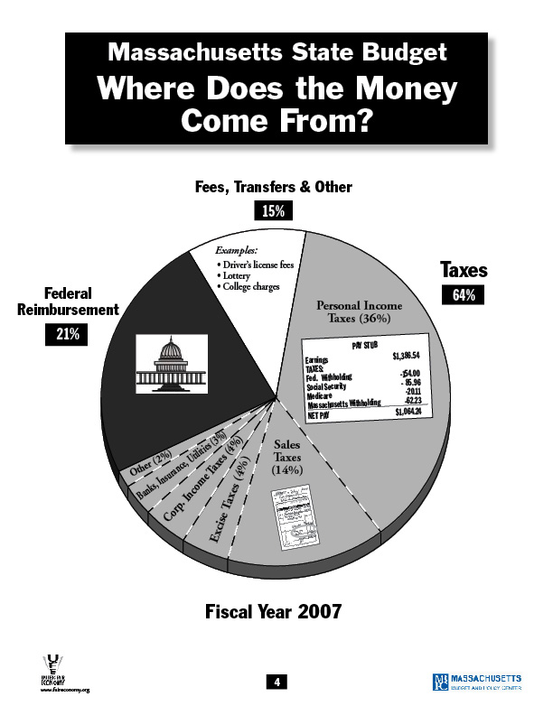

From Massachusetts Budget Crisis: Who Hurts? Who Pays? (United for a Fair Economy and the Massachusetts Budget and Policy Center)
Lesson 2: Enrichment/extension

Where Do Massachusetts State Government Taxes Come From?
Where Do They Go?

What taxes do we pay to the state government?
What services do we
get in return?

Taxes (Money) We Give To the Government |  | Services (Help)We Get From the Government
Kind of Tax:  Who pays it?: |  | Department of Human Services
 |  | 1.
 |  | 2.
 |  | 3.
Kind of Tax:  Who pays it?: |  | Department of Education
Kind of Tax:  Who pays it?: |  | 1.
Kind of Tax:  Who pays it?: |  | 2.
Kind of Tax:  Who pays it?: |  | 3.
Kind of Tax:  Who pays it?: |  | Department of Public Safety  1.
Kind of Tax:  Who pays it?: |  | 2.
Kind of Tax:  Who pays it?: |  | 3.
Kind of Tax:  Who pays it?: |  | Department of Housing
Kind of Tax:  Who pays it?: |  | 1.
Kind of Tax:  Who pays it?: |  | 2.
Kind of Tax:  Who pays it?: |  | 3.
Lesson 2: Enrichment/extension

The Truth about Taxes

Here are some Massachusetts state taxes that we are studying:

Income Tax Corporate Excise Tax Sales Tax

Read the following sentences and think about what tax it's talking about. Circle T if the sentence is true. Circle F if the sentence is false. Be ready to tell the class why you chose your answer.

- If you start a special business called a corporation you have to pay income T F
tax.

- When people go out to a restaurant and drink alcohol with their dinner, T F
they have to pay sales tax on everything.

- Supermarkets charge Massachusetts state tax on only some of their T F
products.

- Everyone who works must pay state income tax. T F

- If you work for yourself, you don't have to pay income tax. T F

- If you buy a package of cigarettes or some alcohol, the sales tax is T F
on the receipt.

- Elderly people who are retired and receive social security checks don't T F
pay income tax.

- Convenience stores (Store 24, Cumberland Farms) charge more sales T F
tax than supermarkets.

- When you buy a used car, you still have to pay sales tax. T F

- Corporations are the only businesses that pay corporate excise tax. T F

- There is no sales tax on prescription medicine in Massachusetts. T F

- Your boss doesn't have to pay income tax. T F

Answers:

- F: Corporations have to pay corporate excise tax.

- T: While the sales tax for the food will show on the bill, there is a special sales tax on alcohol that doesn't show on the bill, but is part of the cost of the alcohol.

- T: Supermarkets charge sales tax on most non-food products including beauty and many household products. Food is considered by the government to be a basic survival need, so they don’t' tax people for food bought at a supermarket.

- T: Everyone who works legally, or who has a social security number must pay income tax. Some people work illegally or "under the table" and don't pay income tax but this is against the law.

- F: False, even if you work for yourself or "you have your own business", you still must pay the government income tax. Depending on what kind of business you have, you may have to pay a different kind of tax, like corporate excise tax.

- F: Even though cigarettes and alcohol are taxed in Massachusetts, the sales tax is "hidden" which means it's part of the price. The price is higher because of the tax.

- T: Elderly people who are retired and have worked when they were younger get income from the government called social security. They don't pay tax on this money.

- F: Even though convenience stores charge more for their products, they charge the same sales tax amount as supermarkets.

- T: Whether you buy a new car or a used car, you have to pay sales tax.

- T: Other businesses pay different state taxes, like income tax.

- T: The Massachusetts state government does not require drug retailers to charge for sales tax. In 2002 though, the state government charged the retailers more for taxes and many retailers passed this cost on to customers.

- F: Yes, even your boss, as long as s/he's is working legally, pays income tax.
Lesson 2 Assessment

Student name_________________________________ Date________________

- Here is the information you will learn in this lesson. Before class begins, only look at the information below, to see what you will learn.

- After the lesson, when your teacher tells you to, circle what you have learned.

I can identify types of taxes:

Personal income Sales Corporate excise

I can say that taxes pay for government services:

Yes No

Student name_________________________________ Date________________

- Here is the information you will learn in this lesson. Before class begins, only look at the information below, to see what you will learn.

- After the lesson, when your teacher tells you to, circle what you have learned.

I can identify types of taxes:

Personal income Sales Corporate excise

I can say that taxes pay for government services:

Yes No

