Lesson 1: Activity 1
Massachusetts State Government

Departments and Services Worksheet

How does each state government department help people?
Write your answers below.
Health and Human Services Department | Education  Department | Public Safety Department | Housing Department
Service 1: | Service 1: | Service 1: | Service 1:
Service 2: | Service 2: | Service 2: | Service 2:
Service 3: | Service 3: | Service 3: | Service 3:

Lesson 1: Activity 1 - Where Does the Money Go?

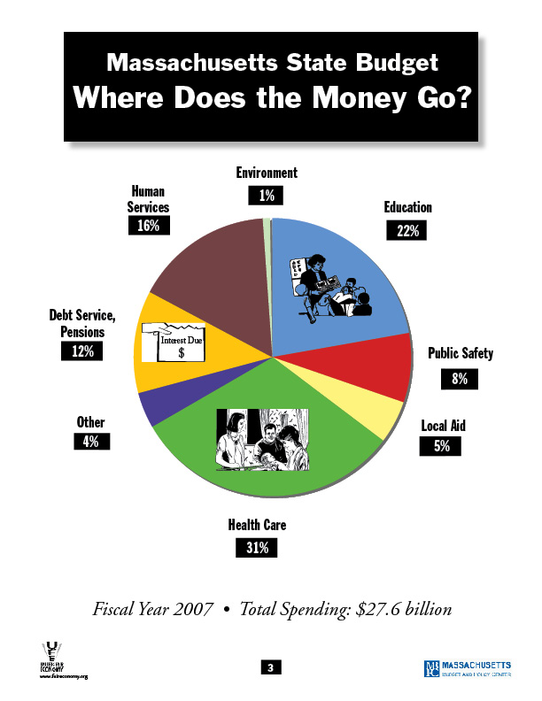

From Massachusetts Budget Crisis: Who Hurts? Who Pays? (United for a Fair Economy and the Massachusetts Budget and Policy Center)
Lesson 1: Activity 2 - Government Services Scenarios

*This can be used as an oral or written activity, depending on the level of the group, and/or the language skill being focused on: listening, speaking, reading, writing, critical thinking, etc. Students can respond individually or you can have them work in teams/groups with one or more of the scenarios and have them formally present their findings to the class.

Tell students: Listen to (read) the following scenarios and name the appropriate government service(s) and/or departments.

- Ana is a single mother with three children, aged 6 months, 2 years old, and 3 years old. She knows she needs to get a job to take care of herself and her family. She can't afford to pay for child-care right now, so she doesn't work outside the home, but stays home and takes care of the children. Until her children start school, the government is helping Ana and her family. Is Ana receiving any services from the state government? What service(s)?

Possible Answers: Welfare, food stamps, WIC, section 8, rental assistance. When the children are of school age, the government will provide public education for them.

- Mike is the first child in his family to go to college. His family is very proud of him. They want him to get his college degree, but they don't have enough money to pay for his college education. Mike decides to go to a state college part-time at night, so he can work during the day to pay for it. His college costs a lot less than the private colleges. He is happy that he has the opportunity to go to college. What department of the state government is helping Mike? How?

Answer: The Board of Higher Education. It is making the cost of college low, so he can pay for it.

- Katrina lives in Massachusetts. When she was driving to ESL class yesterday, she got into a terrible accident. As she was going through an intersection, another car hit her, but did not stop. Lucky for Katrina, she saw the license plate number of the car that hit her. Other people also saw the accident. When a police officer came, Katrina gave the number to him. The police found the driver. The person who hit Katrina must now pay to fix her car. Did the state government help Katrina? How did it help her? What services were available to her because she lives here?

Possible answers: The Department of Public Safety helped her in two ways. Because cars have license plates, she could find the person who hit her. Also, the police helped her find the person and enforce the law to make him/her pay for repairs to her car. Because Katrina lives in Massachusetts, she may also be receiving a service from the Department of Education: a free ESL class!

- After completing a required homebuyer's class, John bought his first home. He did
not have to pay a "down payment" and the interest on his loan is very low, because the state government helped him. Before John "passed papers" or completed the purchase of his home, he had to get the smoke detectors checked, so he made an appointment with a firefighter from the local firehouse. What state government services did John use? Where would John be without these services?

Answer: John used the Department of Housing and Community Development's program for low-income first-time homebuyers. He also used the service of the fire department. Without the first-time homebuyer’s program offered by the state, John probably would not be able to afford his own a home. He also would not be safe without the fire fighters inspection and advice.

- Maria has worked for a local Electronics Company for 40 years and will be retiring next year. She's not too worried about retiring, because she has saved well her whole life. Besides, now here's a chance for her to go back to college! Her kids have told her how she can get free tuition because she's over 55 years old. She does worry a little though about her health. Her employer's health coverage will end when she leaves, but she won't be able to get government help for a few years. Maria hopes that by keeping active, she will stay healthy and not have to go to the doctor that much. Is Maria using any government services now? Will she use any in the future? If so, what?

Answer: The story does not mention whether Maria is using any services of the government now, but it does talk about the future. When Maria retires, she is depending on the government for health insurance coverage and free college classes.

- Jose works very hard at not one, but two jobs. Even though he works almost full-time at both of his jobs, Jose's family does not have health insurance. He is glad, though that his young children can still have regular doctor and dentist visits. He is also happy that his rent is a lot lower than his friends, who live in a different neighborhood. Is the state government helping Jose and his family? How?

Answer: Yes, the state government is helping Jose in several ways. His children can receive healthcare coverage, including going to the doctor and to the dentist, until they are 18 years old. Jose and his wife may also qualify for and be receiving state health insurance called MassHealth. Jose may also be living in an apartment that is required by the state to have lower rent. His children, if they are 5 or more years old, probably go to public school, which is paid for by the state government and by the local government.
Lesson 1: Enrichment/extension
Government Services Guide
What government departments offer these services?
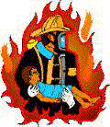
Elementary (Primary) School
High School (Secondary) School
Adult Basic Education
Adult English Class
GED class
Emergency Healthcare
Health Insurance for
the Uninsured
Dental Healthcare
Medicaid
Healthcare for the Elderly
Prescription Medicine
Fire Protection
Police Protection
Motor Vehicles Department
Car Safety
Jail for Criminals/Corrections
First-time Home-Buyers Programs
Food Stamps,
Transitional Assistance and
"WIC" Programs
Community College
State College
State University

Preventative Healthcare
Rental Assistance Program, '"Section 8"
Medicaid
Healthcare for the elderly
Lesson 1 Assessment

Student name_________________________________ Date________________

- Here is the information you will learn in this lesson. Before class begins, only look at the information below, to see what you will learn.

- After the lesson, when your teacher tells you to, circle what you have learned.

I can list four state government departments:

Health and Human Services Education

Public Safety Housing

I can give examples of services each department offers:
Circle 1 = I know 1 example Circle 2 = I know 2 examples

Health and Human Services 1 2 Education 1 2

Public Safety 1 2 Housing 1 2

Student name_________________________________ Date________________

- Here is the information you will learn in this lesson. Before class begins, only look at the information below, to see what you will learn.

- After the lesson, when your teacher tells you to, circle what you have learned.

I can list four state government departments:

Health and Human Services Education

Public Safety Housing

I can give examples of services each department offers:
Circle 1 = I know 1 example Circle 2 = I know 2 examples

Health and Human Services 1 2 Education 1 2

Public Safety 1 2 Housing 1 2

Lesson 2: Warm-up

Joe the Taxpayer
MASSACHUSETTS
STATE GOVERNMENT
Lesson 2: Activity - Where Does the Money Come From?

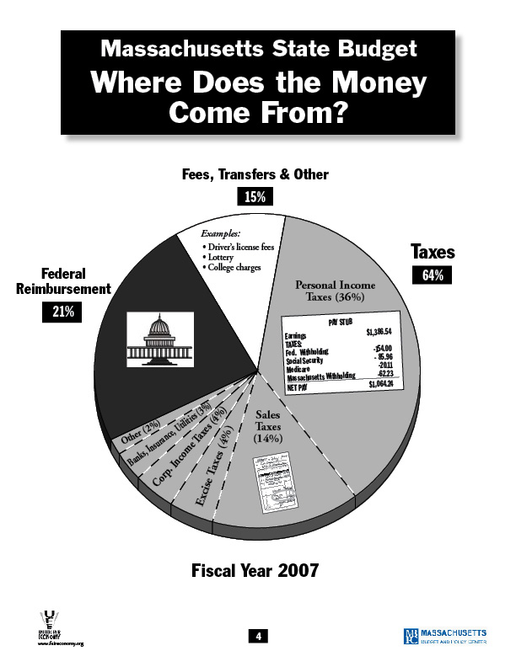

From Massachusetts Budget Crisis: Who Hurts? Who Pays? (United for a Fair Economy and the Massachusetts Budget and Policy Center)
Lesson 2: Enrichment/extension

Where Do Massachusetts State Government Taxes Come From?
Where Do They Go?

What taxes do we pay to the state government?
What services do we
get in return?

Taxes (Money) We Give To the Government |  | Services (Help)We Get From the Government
Kind of Tax:  Who pays it?: |  | Department of Human Services
 |  | 1.
 |  | 2.
 |  | 3.
Kind of Tax:  Who pays it?: |  | Department of Education
Kind of Tax:  Who pays it?: |  | 1.
Kind of Tax:  Who pays it?: |  | 2.
Kind of Tax:  Who pays it?: |  | 3.
Kind of Tax:  Who pays it?: |  | Department of Public Safety  1.
Kind of Tax:  Who pays it?: |  | 2.
Kind of Tax:  Who pays it?: |  | 3.
Kind of Tax:  Who pays it?: |  | Department of Housing
Kind of Tax:  Who pays it?: |  | 1.
Kind of Tax:  Who pays it?: |  | 2.
Kind of Tax:  Who pays it?: |  | 3.
Lesson 2: Enrichment/extension

The Truth about Taxes

Here are some Massachusetts state taxes that we are studying:

Income Tax Corporate Excise Tax Sales Tax

Read the following sentences and think about what tax it's talking about. Circle T if the sentence is true. Circle F if the sentence is false. Be ready to tell the class why you chose your answer.

- If you start a special business called a corporation you have to pay income T F
tax.

- When people go out to a restaurant and drink alcohol with their dinner, T F
they have to pay sales tax on everything.

- Supermarkets charge Massachusetts state tax on only some of their T F
products.

- Everyone who works must pay state income tax. T F

- If you work for yourself, you don't have to pay income tax. T F

- If you buy a package of cigarettes or some alcohol, the sales tax is T F
on the receipt.

- Elderly people who are retired and receive social security checks don't T F
pay income tax.

- Convenience stores (Store 24, Cumberland Farms) charge more sales T F
tax than supermarkets.

- When you buy a used car, you still have to pay sales tax. T F

- Corporations are the only businesses that pay corporate excise tax. T F

- There is no sales tax on prescription medicine in Massachusetts. T F

- Your boss doesn't have to pay income tax. T F

Answers:

- F: Corporations have to pay corporate excise tax.

- T: While the sales tax for the food will show on the bill, there is a special sales tax on alcohol that doesn't show on the bill, but is part of the cost of the alcohol.

- T: Supermarkets charge sales tax on most non-food products including beauty and many household products. Food is considered by the government to be a basic survival need, so they don’t' tax people for food bought at a supermarket.

- T: Everyone who works legally, or who has a social security number must pay income tax. Some people work illegally or "under the table" and don't pay income tax but this is against the law.

- F: False, even if you work for yourself or "you have your own business", you still must pay the government income tax. Depending on what kind of business you have, you may have to pay a different kind of tax, like corporate excise tax.

- F: Even though cigarettes and alcohol are taxed in Massachusetts, the sales tax is "hidden" which means it's part of the price. The price is higher because of the tax.

- T: Elderly people who are retired and have worked when they were younger get income from the government called social security. They don't pay tax on this money.

- F: Even though convenience stores charge more for their products, they charge the same sales tax amount as supermarkets.

- T: Whether you buy a new car or a used car, you have to pay sales tax.

- T: Other businesses pay different state taxes, like income tax.

- T: The Massachusetts state government does not require drug retailers to charge for sales tax. In 2002 though, the state government charged the retailers more for taxes and many retailers passed this cost on to customers.

- F: Yes, even your boss, as long as s/he's is working legally, pays income tax.
Lesson 2 Assessment

Student name_________________________________ Date________________

- Here is the information you will learn in this lesson. Before class begins, only look at the information below, to see what you will learn.

- After the lesson, when your teacher tells you to, circle what you have learned.

I can identify types of taxes:

Personal income Sales Corporate excise

I can say that taxes pay for government services:

Yes No

Student name_________________________________ Date________________

- Here is the information you will learn in this lesson. Before class begins, only look at the information below, to see what you will learn.

- After the lesson, when your teacher tells you to, circle what you have learned.

I can identify types of taxes:

Personal income Sales Corporate excise

I can say that taxes pay for government services:

Yes No

Lesson 3: Activity 1
Types of Tax Systems
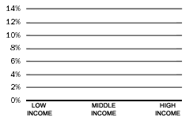
Low Income
Middle Income
High Income
Regressive

When people who have more money pay a smaller part (percentage) of their income in tax than people who have less money, it's called a "regressive" tax system.

Low Income
Middle Income
High Income
Flat

When all people pay about the same part (percentage) of tax on their income, it's called a "flat" tax system.

Progressive
Low Income
Middle Income
High Income

When people who have more money pay a higher part (percentage) of their income in tax than people who have less money, it's called a "progressive" tax system.

Adapted from Massachusetts Budget Crisis: Who Hurts? Who Pays? (United for a Fair Economy and the Massachusetts Budget and Policy Center)

Lesson 3: Activity 1 - Types of Tax Systems bars for graphs

Bars for Regressive Tax:




T
A
X
T
A
X
T
A
X

Bars for Flat tax:

T
A
X
T
A
X
T
A
X

Bars for Progressive Tax:

T
A
X
T
A
X
T
A
X
Adapted from Massachusetts Budget Crisis: Who Hurts? Who Pays? (United for a Fair Economy and the Massachusetts Budget and Policy Center)

Lesson 3: Activities 1 and 2 - Types of Tax Systems matching activity
Types of Tax Systems
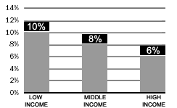
T
A
X
T
A
X
T
A
X
Low Income
Middle Income
High Income
Regressive

When people who have more money pay a smaller part (percentage) of their income in tax than people who have less money, it's called a "regressive" tax system.

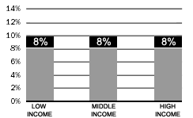
T
A
X
T
A
X
T
A
X
Low Income
Middle Income
High Income
Flat
When all people pay about the same part (percentage) of tax on their income, it's called a "flat" tax system.

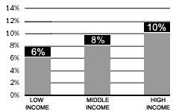
Progressive
T
A
X
T
A
X
T
A
X
Low Income
Middle Income
High Income

When people who have more money pay a higher part (percentage) of their income in tax than people who have less money, it's called a "progressive" tax system.

Adapted from Massachusetts Budget Crisis: Who Hurts? Who Pays? (United for a Fair Economy and the Massachusetts Budget and Policy Center)

Lesson 3: Activity 3 – Who pays state and local taxes?

Lesson 3: Activity 3 - Tax Breaks

Taxes paid before Taxes paid now

Lesson 3: Activity 3

Lesson 3: Activity 3 - Tax Breaks examples
Taxes paid before Taxes paid now

Massachusetts income tax cut

Taxes paid before Taxes paid now

Corporate tax break
Lesson 3: Activity 3 - Tax Breaks worksheet

Name________________________________________________________________________

Here are the names of the tax breaks we talked about:
Taxes paid before Taxes paid now Taxes paid before Taxes paid now

Corporate tax breaks Massachusetts income
tax cut

Here are some situations. Write the correct tax break under the situation.

- It is 1994. The company Fidelity Investments sells one of their products (mutual funds). It pays taxes to the Massachusetts government on the money it makes. Now it is 1996. Fidelity Investments sells some more mutual funds. It pays less money for taxes than it paid in 1994.

____________________________________________________________________________________

- It is 1999. Abdulle makes $1 million at his job. He pays taxes to the Massachusetts government on this money. Now it is 2001. Abdulle makes the same amount of money, but he pays over $5,000 less for taxes than he paid in 1999.

_____________________________________________________________________________

- It is 1994. The company Raytheon sells some airplanes. It pays taxes to the Massachusetts government on the money it makes. Now it is 1996. Raytheon sells some more airplanes. It pays less money for taxes than it paid in 1994.

_____________________________________________________________________________

- It is 1999. Sandra makes $20,000 at her job. She pays taxes to the Massachusetts government on this money. Now it is 2001. Sandra makes the same amount of money, but she pays only about $85 less for taxes than she paid in 1999.

_____________________________________________________________________________
Lesson 3 Assessment

Student name_________________________________ Date________________

- Here is the information you will learn in this lesson. Before class begins, only look at the information below, to see what you will learn.

- After the lesson, when your teacher tells you to, circle what you have learned.

You can name and describe 3 tax systems:

Regressive Progressive Flat
You can name and describe 2 tax breaks:

Corporate tax breaks Massachusetts income tax cut
You can say why you think one way to tax people or one tax break is
fair or not fair:

Yes No

Student name_________________________________ Date________________

- Here is the information you will learn in this lesson. Before class begins, only look at the information below, to see what you will learn.

- After the lesson, when your teacher tells you to, circle what you have learned.

You can name and describe 3 tax systems:

Regressive Progressive Flat
You can name and describe 2 tax breaks:

Corporate tax breaks Massachusetts income tax cut
You can say why you think one way to tax people or one tax break is
fair or not fair:

Yes No

Lesson 4: Activity - Set of large pictures of advocacy methods


Go to a rally.
Lesson 4: Activity - Set of large pictures of advocacy methods



Write legislators.
Lesson 4: Activity - Set of large pictures of advocacy methods

Call legislators.
Lesson 4: Activity - Set of large pictures of advocacy methods

Visit legislators.
Lesson 4: Activity - Set of large pictures of advocacy methods

Vote.
Lesson 4: Activity - Set of large pictures of advocacy methods

Vote Maria
For
Senator

Help candidates and
legislators who support a service you need.

Lesson 4: Enrichment/extension - Set of small pictures of advocacy methods

Write legislators.
Go to a rally.
Visit legislators.
Call legislators.
Vote Maria
For
Senator

Help candidates and legislators
Vote. who support a service important to you.

Lesson 4: Enrichment/Extension - Pictures of general advocacy method

Lesson 4 Assessment

Student name_________________________________ Date________________

- Here is the information you will learn in this lesson. Before class begins, only look at the information below, to see what you will learn.

- After the lesson, when your teacher tells you to, circle what you have learned.

You can give examples of ways to keep money (advocate) for classes and for other services:

Go to a rally. | Write legislators. | Call legislators. | Visit legislators. | Vote. | Help candidates and legislators who support a service important to you.

Student name_________________________________ Date________________

- Here is the information you will learn in this lesson. Before class begins, only look at the information below, to see what you will learn.

- After the lesson, when your teacher tells you to, circle what you have learned.

You can give examples of ways to keep money (advocate) for classes and for other services:

Go to a rally. | Write legislators. | Call legislators. | Visit legislators. | Vote. | Help candidates and legislators who support a service important to you.

Lesson 5: Activity - Steps for advocacy methods

Write a letter to your legislators:

1. Find out how to write a business letter.

2. Find out your legislators' addresses.
Prepare what you want to write.
Write your letters and check them.

3.
Mail your letters.

Call your legislators:

1. Prepare what to say.

2. Practice saying it.

3. Find out your legislators' phone
numbers and call.

Visit your legislators:

- Call your legislator. Find out if s/he will be in
your neighborhood, or make an appointment to
visit at his/her office.

2. Prepare what you want to say.
3. Practice saying it.

4. Wear appropriate clothes.

5. Visit with your legislator.
Vote:
1. Get a voter registration card.
Fill it out and give it to the correct office.

2. Find out about election dates.

- 3. Get information about candidates.
Decide on the one you like best.

4. Vote.

Go to a rally:

1. Get information about rallies from your program, community organizations, friends, or newspapers.
Decide if you respect the organization that is having the rally.
Decide if you believe in the purpose of the rally.

- Talk to people to find out what you should do at a rally.

3. Go to the rally.

Help candidates and legislators who support ABE:

- Find out names of the governor and your legislators.
If it is an election year, find out names of people who
want to be elected (candidates).

- Find out if the governor, legislators, or
candidates support the services important to you.

- Contact their offices to see how you can
help them with their work.

Lesson 5: Activity - Suggestions for Speaking to and Writing the Governor and Legislators

Who to call, visit, or write:
- Senator_______________________________________________________
- Representative_________________________________________________
- Senate President________________________________________________
- House Speaker_________________________________________________
- Governor______________________________________________________

What to say:
- My name is_______________________________________________
- I am a resident of the legislator's district. I live at _______________________
- I would like to ask my legislator to support____________________________
If you know the line item number (the part of the budget), give that information. For example, the line item number for adult basic education is #7035-0002.
- It is important to me because______________________________________
- Thank you. Goodbye.

An example to support ABE classes:
- I am a student at________________________________________________
- The program is important to me because_____________________________
- Without this program I can not/will not_______________________________
- I had to wait _____________________months/years to get into this program.
- Please give more money for adult basic education so more adults like me can learn to read and write better, learn to speak English better, study for their high school diploma, or become citizens. Thank you.

Lesson 5 Assessment

Student name_________________________________ Date________________

- Here is the information you will learn in this lesson. Before class begins, only look at the information below, to see what you will learn.

- After the lesson, when your teacher tells you to, circle what you have learned.

You can choose one way people can support a service (advocate). You can explain how to do it. Circle one:

4 | 3 | 2 | 1
All of the steps are in order. | Most of the steps are in order. | Some of the steps are in order. | None of the steps are in order.

Student name_________________________________ Date________________

- Here is the information you will learn in this lesson. Before class begins, only look at the information below, to see what you will learn.

- After the lesson, when your teacher tells you to, circle what you have learned.

You can choose one way people can support a service (advocate). You can explain how to do it. Circle one:

4 | 3 | 2 | 1
All of the steps are in order. | Most of the steps are in order. | Some of the steps are in order. | None of the steps are in order.

Student name_________________________________ Date________________

Review this sheet before you begin the lesson. After you complete the lesson, circle what you know.

You can choose one way people can support a service (advocate). You can explain how to do it. Circle one:

4 | 3 | 2 | 1
All of the steps are in order. | Most of the steps are in order. | Some of the steps are in order. | None of the steps are in order.

Lesson 6: Activity 1 - Pictorial signs

Governor
Lesson 6: Activity 1 - Pictorial signs
Representatives
Lesson 6: Activity 1 - Pictorial signs
Senators

Lesson 6: Activity 2 - Massachusetts State Budget Process
Governor
Representatives
Senators
At the beginning of the budget cycle, the governor finds out what the different departments need for money for the coming (fiscal) year. Then, in January or February, he or she completes his/her budget that shows what services he/she thinks taxpayers in Massachusetts should get.

1
In March, the representatives complete their budget that shows what services they think taxpayers in Massachusetts should get. The different departments of the state help the representatives create this budget. The representatives can agree, disagree or ignore the governor's budget when creating their budget. Next the representatives debate (talk about, argue!) their budget to make sure they all agree that it is the best it can be. Finally, the representatives vote on their budget to make it final.
2
In April, the senators complete their budget. The different state departments also help the senators create this budget. The senators can agree, disagree or ignore the representatives and the governor's budgets. The senators also debate and vote on their budget.
3
In May and June, a special group of people called the Ways and Means Conference Committee meet and take both the senators' budget and the representatives' budget and combine them or make them one. Then all the representatives and senators vote "yes" or "no" on this new budget. This is supposed to happen by July 1.

4
Finally, the governor has 10 days after the vote to decide on the budget. The Governor cannot go back to his/her original budget--only veto line items in the Legislative Budget. The representatives and senators can "override" or reverse anything the governor takes away or changes if 2/3 of them disagree and vote on it. When the governor, representatives and senators are finished, the budget is complete and the people will get the services that are included in this final budget.
5
Sometimes, after the budget process, there is a budget crisis. This means that the government does not have enough money to pay for the services that are in the completed budget. If this happens, the government must take back some of the money that they gave to the departments. Some of the government services, for example, education, could be cut or reduced. The governor, the representatives, and the senators could decide what services are cut or reduced. During certain times of "emergency", the governor can take away money and services without agreement from the representatives and senators.
6
The state budget process takes a different amount of time each year. Massachusetts has been late with its budget many times.

Lesson 6: Enrichment/extension – Legislator Contact Cards

My Legislators

Governor______________________________________
Office #_________Telephone__________________ Email______________________________________
Senator___________________________________
Office #_________Telephone__________________ Email______________________________________
Senator___________________________________
Office #_________Telephone__________________ Email______________________________________
Representative_____________________________
Office #_________Telephone__________________ Email______________________________________
Representative_____________________________
Office #_________Telephone__________________ Email______________________________________

My name:______________________________________
My Legislators

Governor______________________________________
Office #_________Telephone__________________ Email______________________________________
Senator___________________________________
Office #_________Telephone__________________ Email______________________________________
Senator___________________________________
Office #_________Telephone__________________ Email______________________________________
Representative_____________________________
Office #_________Telephone__________________ Email______________________________________
Representative_____________________________
Office #_________Telephone__________________ Email______________________________________

My name:______________________________________
Lesson 6 Assessment
Mitt Romney
Robert S. Creedon Jr.
Mitt Romney
Robert S. Creedon Jr.
Legislator Pictures

Student name_________________________________ Date________________

- Here is the information you will learn in this lesson. Before class begins, only look at the information below, to see what you will learn.

- After the lesson, when your teacher tells you to, circle what you have learned.

4 | 3 | 2 | 1
Who?  1. Identify elected state legislators from your own district.  2. You can show that all legislators help decide the budget and where tax money is spent. | - You can give the names and the titles of the governor, the senators, and representatives from your district.  - You can show that legislators either help decide the budget or where tax money is spent. | - You can give the name and/or title of at least the governor.  - You can show that legislators help decide the budget or where tax money is spent. | - You can give the name or title of some legislators.  - You can show that legislators help decide where tax money is spent.

Student name_________________________________ Date________________

- Here is the information you will learn in this lesson. Before class begins, only look at the information below, to see what you will learn.

- After the lesson, when your teacher tells you to, circle what you have learned.

4 | 3 | 2 | 1
Who?  1. Identify elected state legislators from your own district.  2. You can show that all legislators help decide the budget and where tax money is spent. | - You can give the names and the titles of the governor, the senators, and representatives from your district.  - You can show that legislators either help decide the budget or where tax money is spent. | - You can give the name and/or title of at least the governor.  - You can show that legislators help decide the budget or where tax money is spent. | - You can give the name or title of some legislators.  - You can show that legislators help decide where tax money is spent.

Lesson 7 Assessment

Student name_________________________________ Date________________

- Here is the information you will learn in this lesson. Before class begins, only look at the information below, to see what you will learn.

- After the lesson, when your teacher tells you to, circle what you have learned.

Pick one way people can support ABE funding. You can explain why you want to do it.
Or, you can explain why you do not want to do it or why you can not do it.

3 | 2 | 1
You can explain why or why not.  You give more than 1 reason. | You can explain why or why not.  You give 1 reason. | You can not explain why or why not.

Student name_________________________________ Date________________

- Here is the information you will learn in this lesson. Before class begins, only look at the information below, to see what you will learn.

- After the lesson, when your teacher tells you to, circle what you have learned.

Pick one way people can support ABE funding. You can explain why you want to do it.
Or, you can explain why you do not want to do it or why you can not do it.

3 | 2 | 1
You can explain why or why not.  You give more than 1 reason. | You can explain why or why not.  You give 1 reason. | You can not explain why or why not.

Lesson 8: Activity - The Advocacy Decision

Community Issue Research Project

Name: Date:

Let the following questions guide you in your research on a community issue that faces the state or your community and affects you and/or other community members:

- What is the issue?

- What state service or taxes are involved?

- Who is affected by this issue and how?

- What MA state legislators are working on this issue or may be able to help with it?

- What advocacy method do you think would work best with this issue? Why?

Your teacher will request that you complete one or more of the following products to report out to the class about the issue you have chosen to study. Make sure you answer the questions above in your project and consider including text, pictures, audio and other enhancements to best communicate your findings.

Products:

- Word Document
Skills focus: writing, computer

Write a personal opinion essay on why the issue is important to them and what they think should be done about it. Include what advocacy method(s) you recommend and how you can get others involved in the advocacy endeavor.

- PowerPoint presentation
Skill focus: oral presentation, writing, computer

Create a slide presentation on the issue and the impact it is having on the state or the community. Include text, images and even audio clips that help communicate the importance of advocacy for the issue or whether advocacy work has already taken place.

- Excel spreadsheet
Skill focus: analysis, numeracy, computer

Create a spreadsheet that depicts financial aspects of the issue including tax dollars savings/costs implications.

- Community member interviews
Interpersonal, communication: oral, written

Locate three community members and interview them about the issue and how it impacts them, their family or fellow community member. In your written report on the findings, include how knowledgeable they were about the issue and how they became/stay informed about it. Have they advocated about the issue? How?

Lesson 8: Activity - The Advocacy Decision

The Advocacy Decision
A Play about the Massachusetts State Budget Crisis and Advocacy

Setting: An adult basic education program, in the break room and in the classroom.

Characters:
Teacher
Marie, an ABE student
Jose, an ABE student
Demitri, an ABE student
Miguel, an ABE student
Olga, an ABE student
Yi, an ABE student
The Narrator

Narrator: Students Marie, Jose, and Demitri are in the break room at their ABE program talking about the Massachusetts money problems and wondering if their classes will soon end because of these problems. Because they are in different classes, they have not discussed the problem together yet.
Jose: I can't believe that we may not have our classes anymore.
Marie: I know. Our teacher helped us learn how to write letters to some people in the government. She also helped us find the names, addresses, and emails of these people so we can call, email, or visit them.
Jose: You wrote a letter to the president?
Marie: No, to the governor of Massachusetts and some legislators. I have the names of my legislators in my notebook, but it depends where you live. Everyone has certain people who can help them.
Demitri: The government doesn't have any more money to pay for the classes and writing a letter won't help.
Marie: There are 17 people in my class. My teacher and many other people are sending letters too. If enough people call and visit them too, I think it will help a lot. If people want to keep their classes, they should do something.
Jose: (Nodding) I agree.
Demitri: (Crossing his arms and shaking his head) In my opinion, doing those things are not important. The people in government won't really listen or read those letters. The only way you can get their attention is to vote, and we're not citizens, so we can't vote, so forget it.
Narrator: Break ends and all three students go back to their classrooms. The setting is now Demitri's classroom.
Teacher: OK, it looks like everybody's back from break. We need to think about something important for our program now. It's about the money that comes from the government to pay for our classes…
Demitri: Oh, I know, we're going to learn about writing a letter to the Massachusetts government to keep our classes.
Teacher: Yes, good. Tell us, Demitri, you seem to know about the problem.
Demitri: The Massachusetts government doesn't have enough money for our program and some people think writing letters will help.
Teacher: And what do you think Demitri?
Demitri: Only a lot of people voting for a good leader will help.
Teacher: (looking at the class) What does the class think about this?
Miguel: There are a lot of people who can help us keep our class.
Olga: You can do other things, like go to the Massachusetts State House to talk to them. I did this last year when the same thing happened.
Teacher: OK, I think we need to learn more about this. Let's start with where the money comes from for our classes. Who can tell me-- not just the government, but who?
Yi: Taxpayers-- people who pay taxes when they buy stuff and who take money from their paychecks and give the money to the government and the government gives the people things like health care and free classes.
Teacher: Great. The government gets their money from many different taxes and gives many different services, like our class, in return.
Teacher: How about these "government people" that can help with the problem, who are they?
Olga: The ones who are from your city. They represent you.
Teacher: Yes, good. How can we talk to them to let them know about how the problem hurts us?
Olga: Last year, people from this program went on a bus to Boston to meet with their senators and representatives, I think.
Teacher: Yes, many people at different programs did this and maybe they talked to their senators and representatives, or maybe they were in a rally or joined with many other students and teachers to let the government know that the need to keep their classes.
Yi: You can also just call or email them if you need to work and can't go to Boston. -- I think they have local offices too, so if you need to work and can't go to their offices in Boston, you can go to the one they have in your neighborhood.
Teacher: Great job. Let's not forget, as Demitri said, that you could also vote once you're a citizen, to let your senators, representatives, and governor know what you think is important.
Olga: Can we also contact these people at other times?
Teacher: Oh, yes. Thanks, Olga. Let's ask the class that one. (To the class) When else can or should we contact our government leaders?
Miguel and Yi: When you have a problem with your child? When you lose your job?
Olga: Whenever you have problems with the government and what taxes you're giving them and how they are supposed to help you.
Marie: You should also contact them when you want to thank them for their support, or to invite them to come to our program to learn more about it. If we build a relationship with our government leaders, it helps when there is a budget crisis.
Teacher: Great, I can tell you all have learned a lot! So I want you all to know that even if you are not citizens and registered voters in Massachusetts, you can help keep the money for classes by letting the government know how important these classes are to you and your family.
Demitri: I still don't think doing these things can help that much….
All students: Oh yeah? You still have a free class after it happened last year!

The End.

